Kit Cat Club
Newsletter 2018

Over the October half-term we held our last session of the year, so it seems like the right time to let you all know what we have been doing during 2018.

Summer Sun
We enjoyed 5 fantastic Thursday’s during the beautiful summer holidays. We ventured onto Bertie’s Walk and into Chandos Park, played games, Bop-it, head basketball, football, hop scotch and made numerous crafts. We also ate our way through, sausages, burgers, home make chicken nuggets, pizza, jacket potatoes, honey sponge (with honey from Tina & Ray’s bees!!) fruit, jelly, ice cream, hot cross buns, satsuma pumpkins and cake, just to name a few. On the last Thursday of August we had a wonderful day out to Cotswold Wildlife Park, we enjoyed a train ride, being chased by a rather angry pelican, watching the animals and playing in the park. What a treat!
Say hello and wave goodbye!!
As per usual, during the year we have welcomed some new children into the Kit Cat family and after the February half-term session we also bid a fond farewell to our year 7 children. This year none of the year 7 children went to Bitterness Afloat on the Norfolk Broads, however, we are thrilled that some of the former Kit Cat children are still enjoying this Christian sailing holiday and we are further encouraged that as the children leave us, that they are feeding into our church youth group, Blaze which meets on a weekly basis.
Buckingham Community Pantomime
As in previous years, in place of a Christmas party, we took the Kit Cat children to the matinee performance of Alice in Wonderland, which was held on Saturday, 20th January. This year as an extra treat we met at The Centre before the show and had a fish & chip lunch. We all booed, cheered, sang and clapped in all the right places and a great time was had by all.
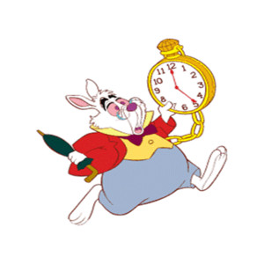

My huge thanks are given to the team of willing volunteers who all give up their valuable time to provide these
children with a wonderful experience, a hot meal, crafts, games, a place for them to just “be” and to show
them God’s love in action. Thank you - Christine.

Isaiah 6:8 Then I heard the voice of the Lord saying, “Whom shall I send? And who will go for us?” And I said, “Here am I. Send me!”

Photos from 2018

