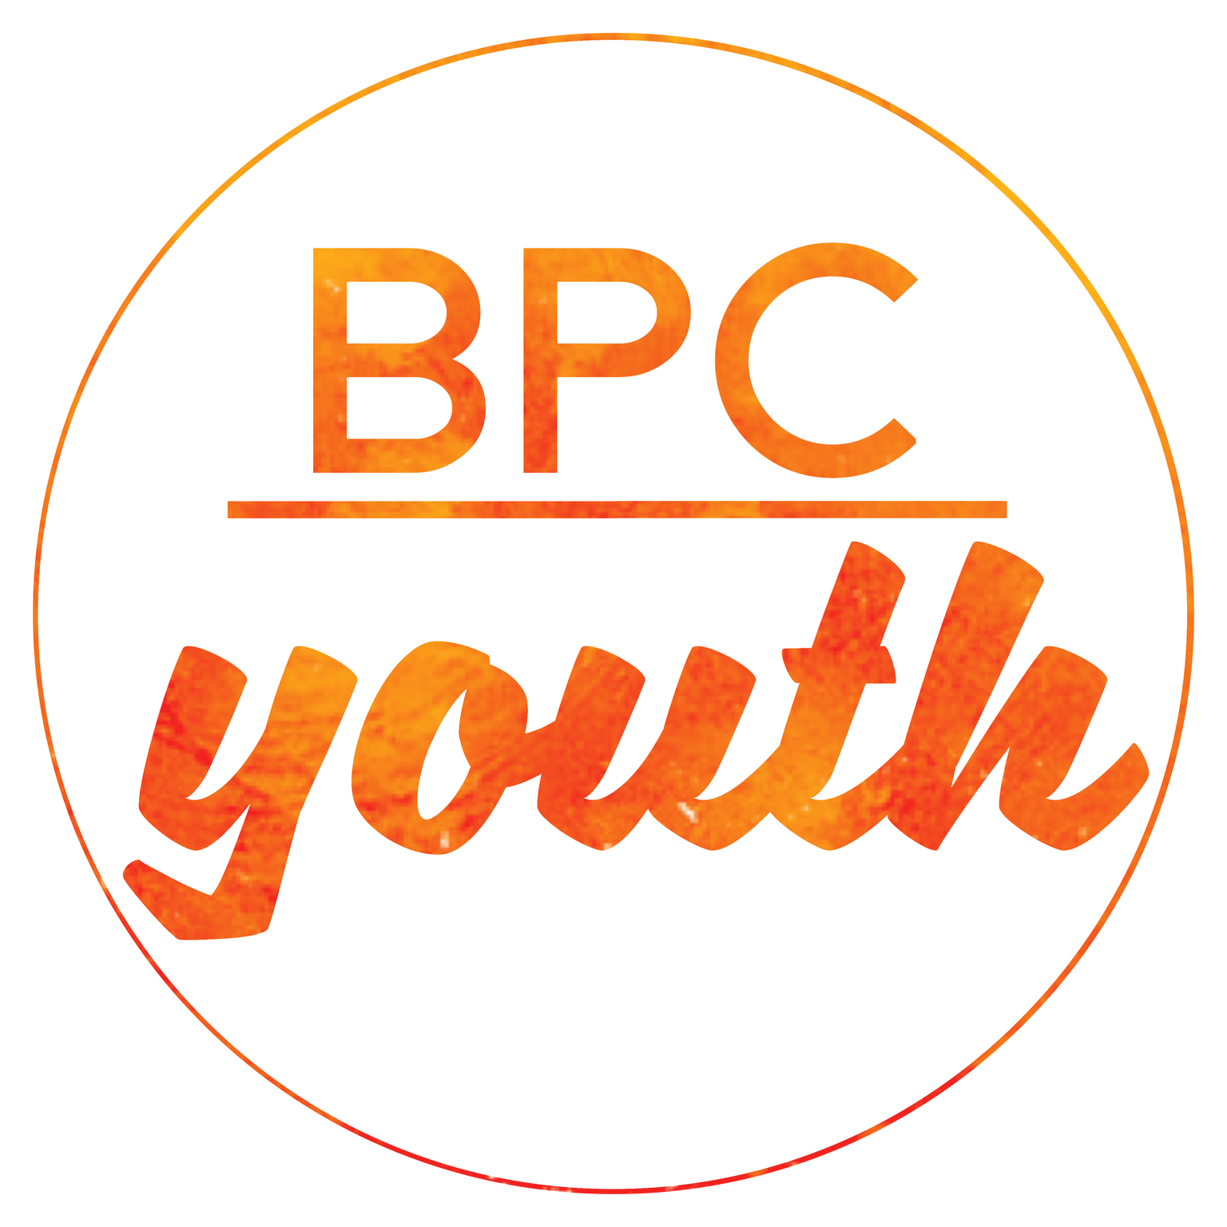
Buckingham Parish Church PCC
BPC Youth Registration and Consent Form

BPC Youth would love to keep in touch with you, we’ll do this under the name of BPC Youth which is run by the PCC of Buckingham Parish Church. It is your responsibility to keep the following information up to date and inform us of any changes. You can withdraw or change your consent at anytime by contacting youth@bpchurch.uk

I consent to BPC Youth contacting me by:
- All methods
- Email
- Text
- Phone call
- Post
- Social media

- I consent to BPC Youth keeping me informed about BPC Youth news, events, activities and services

- I consent to this data being stored in a secure database
Young Person’s Details
I give consent to my child taking part in BPC Youth Acitivities
Full name:…………………………………………………………………………………………………………………..
Address:………………………………………………………………………………………………………………………
Date of birth:………………………………………..

Email address: ……………………………………………………………………………………………………………………………..

Mobile number: ……………………………………………..
School:…………………………………………………………….

Does your child have any special requirements, including: allergies, phobias, dietary requirements, additional needs or is on any medication? Please speak to the Youth Team Leader for further discussion if needed.
………………………………………………………………………………………………………………………………………………………………………………
………………………………………………………………………………………………………………………………………………………………………………

Family doctor’s name:………………………………………………………………………………………………………..
Doctor’s address and telephone:………………………………………………………………………………………..
Parent or Guardian’s Details and Consent
Parent/Guardian’s name:……………………………………………………………………………………………
Relationship to child:………………………………………………………………………………………………….
Telephone (home):…………………………………………….. Mobile:………………………………………
E-mail:…………………………………………………………..

Emergency Contact Details and Consent
Incase we cannot contact you in an emergency
Emergency Contact Name:…………………………………………………….. Contact Number:…………………………………………….
Relationship to child:.................................................................
- In an emergency and if I cannot be contacted I give consent for any medical treatment judged necessary and urgent by a medical practitioner and I authorise the leader in charge to sign any document required by hospital or any other authority.
Other Consent
- Travel to and from group: I give permission for my child to travel from BPC Youth activities without being collected

Photographs: I give permission for BPC Youth to use images (photographs and video) of my child for:

- In house promotional material and purposes
- External promotional material
- social media
- church website
- newpapers

- Off Site: Occasionally we go off site during youth groups. For example, Town wide treasure hunt. This is done safely and as part of our planned youth provision. I give consent for my child to go offsite as part of BPC Youth groups and events.

- Social Media: I give consent for my child to be friends on Facebook with the Youth Team Leaders professional profile which enables communication via facebook messenger. (Profile: Sam-Youth-Graham)
*BPC Youth has two social media public groups – BPC Youth Facebook group and Instagram page, young people and parents may choose to follow these.

Parents/Guardian Signature:…………………………………………………………………… Date:………………………………………

Please refer to Buckingham Parish Church’s Privacy Notice on our website: https://www.bpchurch.uk
The PCC of Buckingham Parish Church is a Registered Charity: Charity Number: 1128704

