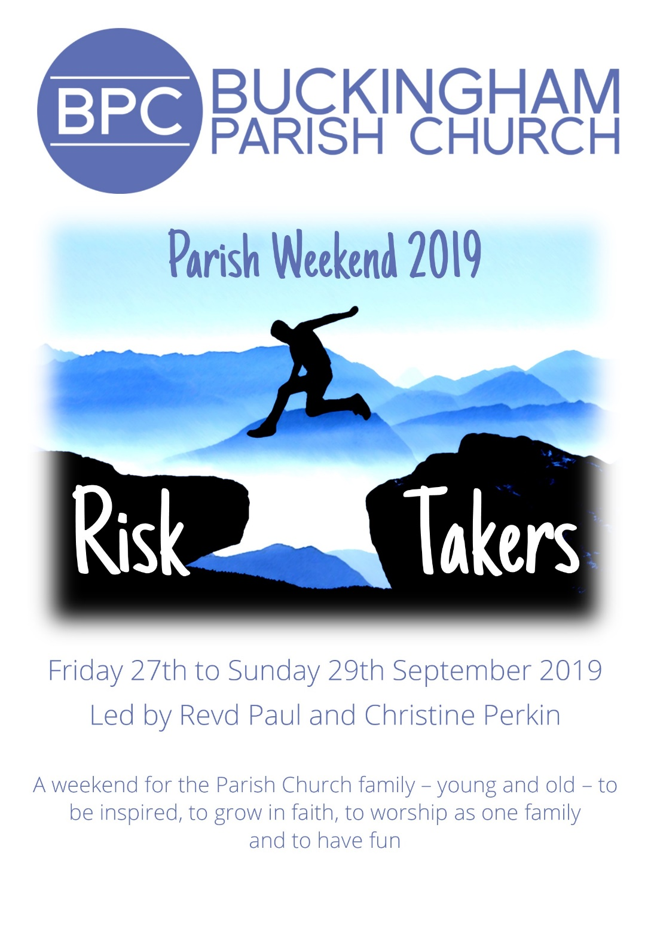

What will we be doing?

The weekend away is a vital part of our church life together and takes place every other year. Each occasion is unique, but every weekend provides a great opportunity for all the church family to get to know one another better as we learn, worship and have fun together.

Our speakers are an anointed couple: Revd Paul Perkin and his wife Christine. In 1987, before church planting was on the national church agenda, Paul and Christine led the second church plant out of Holy Trinity Brompton to St Mark’s Battersea Rise in London, a church that itself has planted out many times in the last 32 years. They are renowned Bible teachers who hold the Word and Spirit tightly together. Christine is herself a sought-after speaker with a renowned women’s ministry. We are exceptionally blessed to have them speak to us on the theme of discipleship in the power of the Spirit. We are promised a time of spiritual refreshment and engagement that we pray will help BPC along a path to renewal.

Their sessions will be on the theme of “Risk taking”

- THE RISK-TAKING GOD
God took the greatest risk in allowing us our freedom but inviting us home to Himself. What risks of invitation can we make to help others come home to Him?

- RISK-TAKING DISCIPLES
Jesus calls all of us to join in His mission despite our hesitations or inadequacies. We might think he took a huge risk in Peter to be the ‘rock’ on which he would build everything!

- A RISK-TAKING CHURCH
When the Spirit came he propelled the church to risk all for the sake of building his people. The priorities for the church today remain the same as in the beginning.

The weekend will include:

Friday Drinks and nibbles then introductions and Session 1.

Saturday morning Breakfast followed by Session 2 at BPC

Saturday 11am Seminars and lunch at the *Royal Latin School.

Saturday afternoon Session 3 at BPC

Saturday evening Evening meal and entertainment

Sunday morning All Age Service with Lord’s Supper
Hog Roast Lunch

The seminar streams include:
- Creativity
- Social action
- Men’s stream
- Women’s stream
- Discipleship
- Theology/Apologetics

*The Royal Latin School is a 10-15 minute walk from the Church please notify Jan in the office if you require transport to this venue.

Booking Form

Weekend rates:
Weekend ticket £30 Children 4-15yrs £10

Children 0-3yrs free Hog roast £5

Weekend tickets are inclusive of refreshments, wine and nibbles on Friday night, breakfast, lunch and dinner on Saturday and Hog Roast and refreshments on Sunday. There will be an organised programme for the children.
NB: Bookings and payments can now be made online via the church website.
Surname | First name | Age if under 16

Address:
Email:
Telephone:
I /we have special dietary requirements (please list below)

Please select which of the seminar streams you would like to attend
Morning seminar | Number attending | Afternoon seminar | Number attending
Creativity |  | Creativity
Discipleship |  | Discipleship
Social action |  | Social action
Men’s stream |  | Men’s stream
Women’s stream |  | Women’s stream
Theology |  | Theology

Instructions for payment overleaf

Paying by cheque
Please make cheques payable to Buckingham PCC and mark on the back ‘Parish Weekend 2019’

Paying by cash
Please attach firmly to your booking form and in an envelope clearly marked with your name(s).

Paying by bank transfer
Please use BPC’s Lloyds account:
Sort code 30-91-39
Account no 00035886
Please reference your transfer with your name and the event as follows: ‘Parish Staycation – Your Name’

Paying by credit/debit card
Bookings and payments can now be made online via the mychurchsuite app (my events calendar) or the link on the church website.

Bursaries
Please contact Jan in the church office if you need financial help or if you would be willing to contribute to a bursary scheme.

PLEASE RETURN THE BOOKING FORM, WITH YOUR DEPOSIT, TO THE CHURCH OFFICE or by EMAIL TO ejocog@gmail.com

