Love Buckingham – ‘Changing the World One Friend at a time’
March 15-22, 2026

Please pray over these events that the mission team will be attending and speaking at

Mission week Timetable

Sunday 15 March:
All services at BPC

Monday 16 March:
Easter Cracked schools’ event
Royal Latin School event on God and Science
Tea and chat at The Centre

Tuesday 17 March:
Market day prayer in town
Coffee and company
Clarendon House service
Community lunch
Private dinner party
Fim night at the Vinson Centre

Wednesday 18 March:
Midweek communion
Stowe School seminar on God v science
Lighthouse
Bread making workshop
Alpha

Thursday 19 March:
Coffee and company
Ark toddler group
Assembly at Lace Hill primary school
Assembly at Buckingham Primary school
Book club
Youth event

Friday 20 March:
Quiz and curry

Saturday 21 March:
Brunch
Street evangelism/healing prayer in town

Sunday 22 March:
All BPC services – guest services

Invite Your Friends to Our Special Mission Week Events!

Tuesday 17th
Film night at the Vinson Centre.
"God's Not Dead"
7pm
£3.99
Mission team will be present

Wednesday 18th
Bread making demonstration 6.30pm at Church.
Free event
There will be a short testimony from one of the mission team.

Friday 20th
Quiz and Curry 6.30pm at Church
A traditional pub quiz.
£5
There will be a short testimony from one of the mission team whilst the papers are being marked.

Saturday 21st
Brunch at The Centre 10.30am – 12noon
£3
A cooked breakfast with a short testimony from the mission team.

Sunday 22nd
GUESTS SERVICES ALL DAY

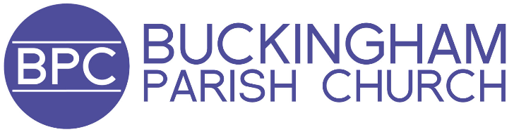
Bpchurch.uk/love

